B. In-Depth Explanation & Analysis
1. Differentiation: The Reason for Layers Earth didn't start with a core, mantle, and crust. It was initially a hot, homogeneous ball of molten material.
- Think of this as: A bottle of salad dressing. If you shake it, it mixes. If you let it sit, the heavy stuff (oil/vinegar mix) separates. Gravity did this to Earth. Heavy iron sank to form the core; lighter silicates floated to form the crust.
2. Seismic Waves: The Earth's X-Rays (Chapter 3) We cannot reach the core (it's too deep and hot). We use earthquakes as natural X-rays.
- P-waves (Primary): Fast, travel through everything (solid, liquid, gas). They vibrate parallel to direction of wave (like sound).
- S-waves (Secondary): Slower, travel only through solids. They vibrate perpendicular to the direction.
- The "Aha!" Moment: S-waves disappear completely after 105° angular distance from an earthquake epicenter. Why? Because something liquid blocked them. That's how we discovered the outer core is liquid.
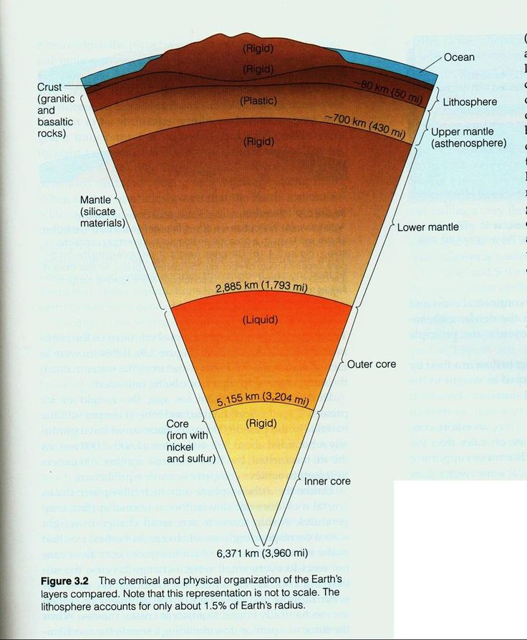
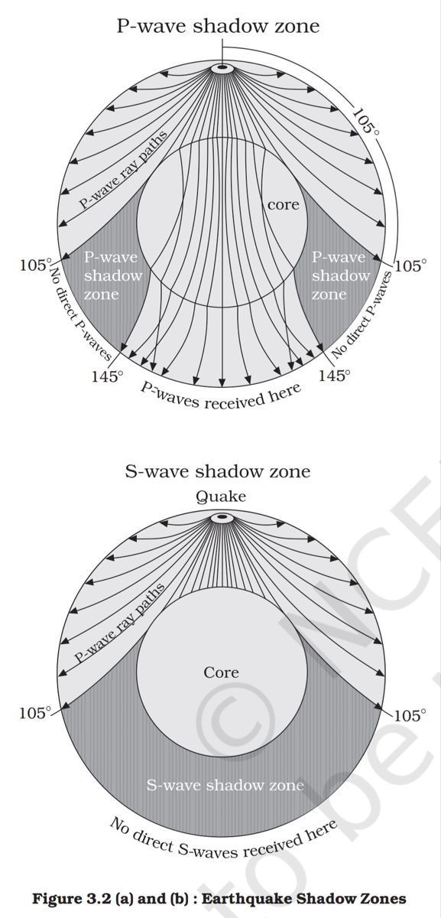
3. Continental Drift vs. Plate Tectonics (Chapter 4) Students often use these terms interchangeably. They are different.
- Continental Drift (Wegener): The observation that continents move. (Analogy: Noticing a car is moving but not knowing it has an engine).
- Plate Tectonics (Modern): The explanation (mechanism) for HOW they move (convection currents in the mantle dragging lithospheric plates). (Analogy: Understanding the engine and wheels that make the car move).
4. Types of Plate Boundaries
- Divergent: Moving apart. Creates new crust. (e.g., Mid-Atlantic Ridge). Think: "Divorce" - splitting up.
- Convergent: Moving together. Destroys crust (subduction) or folds it (mountains). (e.g., Himalayas, Andes). Think: "Collision".
- Transform: Sliding past. Neither creates nor destroys crust, but causes massive earthquakes. (e.g., San Andreas Fault).
Mentor’s insight: (chapter 2) Make sure to remember that the Nebular hypothesis (early theory) was based on the ideas of Immanuel Kant, a German philosopher, which Laplace, a mathematician, later revised.
- The Earth is about 4.6 billion years old, with oceans being 4,000 million years old, and life first began to evolve sometime around 3,800 million years ago. (These dates and names are important to remember for objective questions)
- (chapter 3) Batholiths, lacoliths, lapoliths, phacoliths, sills and dykes are the different types of volcanic landforms.
Make sure to take a good look at the diagrams and labels of the important diagrams as they are often asked in the exams for high-weightage questions.

